Penilaian Kesesuaian Lahan untuk Beberapa Tanaman Pangan Penghasil Karbohidrat pada Lahan Rawa Lebak di Desa Arisan Jaya

Land Suitability Assessment for Some Carbohydrate Food Crops
at Wetland Area in Arisan Jaya

Satria Jaya Priatna¹, Djak Rahman² dan Supriyadi^{3*)}

¹Jurusan Ilmu Tanah, Fakultas Pertanian, Universitas Sriwijaya
²Jurusan Ilmu Tanah, Fakultas Pertanian, Universitas Sriwijaya
³Program Studi Ilmu Lingkungan, Pascasarjana, Universitas Sriwijaya
*⁾Penulis untuk korespondensi: supriyadi.sp.1992@gmail.com

Sitasi: Priatna SJ, Rahman D, Supriyadi. 2020. Land Suitability Assessment for Some Carbohydrate Food Crops at Wetland Area in Arisan Jaya. Jurnal Lahan Suboptimal: Journal of Suboptimal Lands. x(x): xx.

ABSTRACT
The nature condition and lack of knowledge about soil characteristics have become a limitation for crops cultivation and development in Arisan Jaya. This study was aimed to determine the type of crops that has potential to be developed in site. The assessment was carried out in Arisan Jaya, Pemulutan Barat Sub-District, Ogan Ilir Regency, South Sumatera from April to August 2015. The study method is 1:30.000 semi-detailed survey. The location of the sample was determined by grid method with one sample for every 1.000 meters with 10 sample sites. A disturbed soil sample was taken as deep as 150 cm from the ground surface. Land characteristics data were matched with crops growth requirements based on the suitability classes set for wetland rice, dry land rice, corn, cassava and sweet potato. The distribution of soil properties was known by IDW (Inverse Distance Weighting) interpolation method, which was overlapped to determine the distribution of land suitability classes. Very acidic soil conditions was a major limiting factor for crops cultivation in general (the actual suitability class is Nf). Wetland rice was relatively more suitable to be cultivated than dryland rice in the site. Corn and cassava could be planted as rotational crops before the rainy season or after rice season, although the productivity would not be optimal (S2 potential suitability class). Climatic conditions was another limiting factor for the development of sweet potato at the site (S3 potential suitability class).
Keywords: cassava, corn, dry land rice, wet land rice, sweet potato
Running title: Land Suitability Assessment for Carbohydrate Food Crops

ABSTRAK
Kondisi alam dan minimnya pengetahuan tentang karakteristik tanah membuat terbatasnya usaha dan pengembangan budidaya tanaman di Desa Arisan Jaya. Pengkajian bertujuan untuk menentukan jenis tanaman pangan yang berpotensi untuk di kembangkan di lokasi kajian. Studi dilaksanakan di Desa Arisan Jaya, Kecamatan Pemulutan Barat, Kabupaten Ogan Ilir, Sumatera Selatan pada bulan April hingga Agustus 2015. Metode kajian yang digunakan adalah metode survei semi-detail berskala 1:30.000, lokasi sampel ditentukan dengan metode grid pada kerapatan satu sampel setiap 1.000 meter sehingga terdapat 10 lokasi pengambilan sampel. Sampel tanah terganggu diambil sedalam 150 cm dari permukaan tanah. Data karakteristik lahan dicocokkan dengan syarat tumbuh tanaman berdasarkan kelas kesesuaian yang ditetapkan untuk padi ladang, padi sawah, jagung, ubi kayu dan ubi jalar. Sebaran sifat tanah diketahui dengan metode interpolasi IDW (Inverse Distance Weighting) yang ditumpang tindihkan guna mengetahui sebaran kelas kesesuaian lahannya. Kondisi tanah yang sangat masam merupakan faktor pembatas utama pada budidaya tanaman pangan secara umum (kelas kesesuaian aktual Nf). Padi sawah relatif lebih cocok diusahakan di lokasi daripada padi lahan kering. Jagung dan ubi kayu dapat ditanam sebagai tanaman rotasi sebelum musim hujan atau setelah musim tanam padi meskipun produktivitasnya tidak akan optimal (kelas kesesuaian potensial S2). Kondisi iklim menjadi faktor penghambat lainnya untuk pengembangan ubi rambat di lokasi (kelas kesesuaian potensial S3).
Kata kunci: jagung, padi sawah, padi ladang, ubi kayu, ubi rambat
Judul larian: Penilaian Kesesuaian Lahan untuk Tanaman Pangan Penghasil Karbohidrat

INTRODUCTION

Food is one of the basic human needs. Because of its strategic role, food sufficiency also affects social and political life, both nationally and globally. Food security has an important influence on a country's security (Mulyani et al., 2011). There are various types of edible plants that have been cultivated in Indonesia, although the production center for some kinds of crops are only found in certain areas. (Nurchayati & Ardiyansyah, 2019).
The crops that are popularly cultivated in the wetland area are rice and corn (Suriadikarta & Sutriadi, 2007). Paddy, as the most commonly recognized food crop has occupied the majority of food crop agricultural land in Indonesia (Elizabeth, 2011). Rice production in South Sumatra at 2018 has amounted to 2.646.566 tons of rice. This amount is quite high when compared to the average national rice production, which is 1.662.875,71 tons. (BPS & BPPT, 2018). Besides paddy, corn is also an important crop in wetland because it is one of a major food-producing crop and an alternative source of income for farmers. Corn could be cultivated with monoculture or intercropping method. Statistics show that the harvested area of ​​corn at South Sumatra during 2017-2018 increased by 14,033 hectares (BPS, 2019).
Arisan Jaya is located at Pemulutan Barat District, Ogan Ilir Regency, South Sumatra Province, where most of the land is used as paddy fields. The rice field has been a cover for ​​284 Ha of Arisan Jaya (BPS Ogan Ilir, 2019). This rice field has only been cultivated for once a year. The low planting index in rice fields has caused by the land condition that mainly dry than wet.
The nature condition and lack of knowledge about their soil characteristics have become a limiting factor for crop cultivation and development. The same reason was also limiting the types of plants cultivated by residents (Chuzaimah & Febriyansyah, 2016). Therefore, an evaluation of land resources is needed to find out the type of crops that suitable to cultivate in the area.
Land suitability assessment is a way to estimate the land potential for various uses (Sulaeman et al., 2015). The basic framework for land suitability assessment is to compare various conditions for growing plants with an actual land condition to help overcome the competition between many possible land uses (Herwanto et al., 2013). Evaluation of land resources can present a set of objective data that help in decision making at field planning so that land can be used as efficiently as possible (Mulyani et al., 2017). With these matters, an analysis of land suitability for five types of crops was carried out to determine the types of carbohydrate-producing plants suitable to be developed at Arisan Jaya Village, Ogan Ilir Barat District, South Sumatra Province.

RESEARCH METHODOLOGY

The study was conducted at Arisan Jaya, Ogan Ilir Barat District, South Sumatra Province. Analysis of soil chemical and physical properties was carried out at the Soil Physics and Chemistry Laboratory, Soil Science Departement, Faculty of Agriculture, Sriwijaya University, Indralaya. The study was done from April to August 2015.
The research method that used was a semi-detailed level survey method with 1: 30,000 scale map guidance (Indonesia Standardization Agency, 2018). The location of the sample was determined by grid method with one sample for every 1.000 meters with 10 sample sites. A disturbed soil sample was taken as deep as 150 cm from the ground surface. Observation of the location of the study was also carried out in order to collect the data of land conditions in general.
Land characteristics data that was needed for this study is a general land condition (topography, vegetation type, climate and boundaries), soil physical properties (soil texture) and soil chemical properties (pH, total nitrogen (N), available phosphorus (P), exchangeable potassium (K), C-organic content and CEC). Furthermore, the data from field observations and laboratory analysis that have been collected will be matched with the optimal requirements for plant growth based on the level of suitability classes that have been set in order to obtain the actual suitability and potential suitability of site and suggestions for land improvement (CSR/FAO Staffs, 1983).
The types of crops that were assessed is wetland rice, dryland rice, corn, cassava and sweet potato. Distribution of soil properties is mapped using IDW (Inverse Distance Weighting) interpolation method (Martins et al., 2019), which was overlapped to determine the distribution of land suitability classes (Rizal & Herdiansyah, 2016).

RESULTS & DISCUSSION

General Land Condition
Most of the land in Arisan Jaya is a wetland area with water sources that come from rainfall and overflowing rivers during the rainy season, which gradually dries up to the dry season.
Based on climate data in 2005-2014, it is known that the average annual temperature at Arisan Jaya is 27,25 ° C, with the number of dry months as much as 2,3 months per year, and the annual average rainfall is 2150,18 mm per year. So the actual suitability classes are very suitable (S1) for dryland rice and wetland rice, quite suitable (S2) for corn and cassava with a marginal class (S3) for sweet potato.
Through site observation activities, it is known that the research location has a slope value ranging from 0-2% (flatland), which is suitable for most plant cultivation activities and there are no rocks on the surface with more than 150 cm of soil depth. Thus, the topography can be classified into a very suitable class (S1) for all crops. Land drainage class could be classified into a moderately well category. The land drainage conditions are classified into a very suitable class (S1) for rice (wetland and dryland rice), maize and sweet potato except for cassava, which classified to moderately well suitability class (S2) for that drainage condition. When the study was conducted, it is known that several types of commodities commonly cultivated in Arisan Jaya is rice and chilli. Other plants that are also planted by the community in the yard or garden are cassava, banana and sweet potato.

Soil Properties
Nitrogen (N), phosphorus (P) and potassium (K) are essential nutrients that are needed by plants during both vegetative and generative periods. Based on laboratory test results, it is known that the nitrogen content in the soil varies between 0,18 to 0,74 %, the phosphorus content is available between 11,10 to 61,80 ppm, while the content potassium is between 0,20 to 0,77 me/100g. Other soil properties that affect plant growth and development are pH (soil acidity) and CEC (Cation Exchange Capacity). The soil pH value at the location is classified as very acidic, ranging from 3,35 to 3,94 thus classified to not suitable class (N) for all crops, which is become a limiting factor for the development of food crop cultivation at the site. CEC values ​​are classified as high between 26,10 to 32,63 me/100g. The distribution of CEC values ​​is evenly distributed in the soil at the survey site, which is classified as very suitable (S1) for all crops. The soil texture class at the survey site consists of loam to clay-loam texture with conformity classes between S1 (very suitable) and S2 (moderately suitable).

Suitability for Rice
Based on the results of land suitability assessment, wetland rice has better climate suitability (matching temperature and water availability) compared to dryland rice (S1 suitability class for wetland rice and S2 for dryland rice). Dryland rice plants need a slightly cooler temperature between 20-26 ° C with several dry months (between 5-8 months) each year. The condition of rooting media, topography, and soil drainage at the location is quite good to support rice cultivation activities, both wetland rice and dryland rice. Rice generally lives well in locations with good water availability. The availability of water in soil is influenced by soil texture. Soil texture is a combination of sand, dust and clay fraction composition in the soil (Surya et al., 2017). Land with more clay fraction will be able to hold water better when compared to land that tends to have more sand or dust fraction. Thus, there are some suitability constraints (suitability class S2) in some areas that have clay because they are less able to store water when compared to soil with clay-loam texture. Soils with clay to clay-loam textures have an average permeability value of 0,8 to 1,3 that has quite slow permeability (Siregar et al., 2013)
The most significant limiting factor for rice cultivation and development activities at Arisan Jaya comes from the pH value. Overall soil sample has shown a lower than 4 pH value (very acid). That will greatly inhibit the growth and development of rice at the site, which classified as not suitable class (N). The soil CEC values ​​are quite high at the location, thus classified into very suitability class (S1). The soil CEC value is determined by clay content and organic matter in the soil. The higher of CEC value then, the more cations can be retained by the soil (Safrizal et al., 2016), these cations can be easily exchanged by other cations contained in the soil solution so that plants can easily absorb them. For rice cultivation, each of nitrogen, phosphorus and potassium in the soil still needs to be increased through fertilization. In wetland rice, the fertilizer that needs to be added is a type of fertilizer that can increase levels of phosphorus and potassium in the soil, whereas for dryland rice the type of fertilizer that needed is a type that can increase the soil phosphorus content.
Wetland rice and dryland rice has the same actual suitability class (Nf suitability class) with the main limiting factor is the low soil pH level. In addition to pH, there are also a few obstacles due to the low nutrient content and soil texture. These limiting factors can be improved by applying lime and fertilizer to the soil. Dryland rice needs a lower temperature suitability value and lower dry months compared to wetland rice, so the potential suitability class for dryland rice is varied from S2tw to S2twr. If efforts are made to improve the land characteristics, then the suitability class (potential) of wetland rice will increase to S1 and S2r. Thus, the most suitable type of rice to be planted in Arisan Jaya is wetland rice. Dryland rice can be an alternative if water shortages are expected in the dry season. The distribution of land suitability classes for rice can be seen in Figures 1 and 2.
To increased field productivity at the site, some effort can be made by applying lime and fertilizer, especially the type of fertilizer that provides additional phosphorus to the soil. The supply of organic fertilizer can be given to increase the effectiveness and to support the inorganic fertilizers (Marlina et al., 2016). Some selective varieties that quite suitable to be cultivated in wetland fields are Ciherang and Sintanur (Kasno et al., 2016).

Suitability for Corn
According to the results of the land suitability assessment for corn, corn cultivation activities in Arisan Jaya will encounter some obstacles that come from environmental conditions because the air temperature at the location is not the optimal temperature (S2 suitability class) for maize cultivation which should be in 20-26 ° C. The availability of dry months and rainfall has fulfilled the optimum growth requirements of corn. The rooting conditions and topographic factors are also considered at optimal condition, except for the soil texture. In some locations, soil with a clay texture is classified to S2 suitability class. Corn plants have different water sufficiency values ​​than rice where rice requires a state of water-saturated land, whereas corn tends to be better when cultivated in relatively dry locations.
The main limiting factor for cultivation and the development activities of corn at Arisan Jaya comes from the low of soil pH value (N suitability class). Another limiting factor comes from the lack of soil nutrients. The availability of nitrogen and potassium in soil still need a slight increase (S2 suitability class). Phosphorus in the soil will require more addition (S3 suitability class). With these limiting factors, the land suitability level for corn cultivation in Arisan Jaya is in the Nf suitability class with the main limiting factors is soil acidity, air temperature and the lack of soil nutrient. Soil nutrient availability can be improved by applying fertilizer and lime, especially in areas that have acidic properties, so the suitability class potentially increase to S2t.
Almost as the same as rice, the development of corn in the site will need a land improvement first in the form of lime and fertilizer addition especially the fertilizer that can increase phosphorus element in the soil. Fertilization activities can be carried out using organic and inorganic fertilizers. Based on research conducted by Yandi et al at 2016 it is known that the provision of organic fertilizer based on chicken manure in corn plants can provide other benefits besides increasing production, which reduces weed populations on wetland field.

Suitability for Casava
Cassava or usually called as "singkong" in Indonesian can also be found in Arisan Jaya. The community used to plant it in the yard or garden, but it was not as community's main commodity. The average value of rainfall at Arisan Jaya is 2.282,5 mm per year. That rainfall condition is not suitable for cassava cultivation (S2 suitability class) which is more optimally cultivated at 1.000-2.000 mm per year. Another limiting factor for cassava cultivation is a drainage condition (S2 suitability class). Cassava plants are more suitable to be cultivated in soils with fully functional drainage condition but still has good soil moisture.
Just like rice and corn, the process of cassava cultivation also has some limiting factor. The biggest one is the soil acidity that is not suitable for cassava (N Suitability Class). Another limiting factor is the lack of soil nutrient, which requires little fertilizing in the almost entire field. The supporting factors for cassava cultivation in Arisan Jaya are the temperature conditions, the number of dry months, topography, and soil CEC values, which is very suitable for cassava cultivation (S1 Suitability Class).
Generally, the actual suitability class for cassava is classified as not suitable (Nf suitability class) and if the land condition is improved, the suitability class will potentially increase to S2wr. Some inhibitor of the development for cassava cultivation in the location is the amount of average rainfall that was too high and the condition of soil drainage. Cassava planting activities in the study location can be carried out on dryland (not flooded) for 9-10 months or throughout the year due to the length of cultivation activities based on the nature of the cassava that is not resistant to wet soil condition (Rahayu & Saleh, 2013).

Suitability for Sweet Potato
Based on the conditions for growth, sweet potato will grow optimally at a temperature of 20-22 °C. While the average annual temperature in Arisan Jaya is 27,28 °C. With the difference in temperature that is quite far, the suitability class (temperature) for the sweet potato is S3 suitability class. The number of dry months in Arisan Jaya Village is optimal (S1 suitability class) for the cultivation of sweet potato, but the rainfall in Arisan Jaya is a way too high (S2 suitability class). An acidic soil condition is the most significant limiting factor (N suitability class) for sweet potato cultivation at Arisan Jaya. The soil CEC value one of condition that supports sweet potato cultivation in the site. The other factor is soil depth and topography condition. The availability of soil nutrients needs to increase a little, especially the potassium availability in the soil, which is in S2 suitability class. More fertilization will be needed to increase the availability of phosphorus which is in S3 suitability class.
After evaluating the various supporting and limiting factors, then the suitability class for sweet potato could be identified. The actual suitability class of sweet potato is in the Nf class with the soil acidity as the main limiting factor. The other limiting factors are also known is hot air temperature, a heavy amount of rainfall and the lack of soil nutrient availability. Soil acidity and soil nutrient availability could be improved so that the suitability class can rise to S3tw class (potential suitability class).
That means, the the land condition in Arisan Jaya is still not recommended as a location for sweet potato cultivation because of the condition of air temperature, rainfall and the soil texture that does not well support the sweet potato growth. They are limiting factors that are cannot or difficult to improved so that the sweet potato cultivation activities will not be optimal. Nevertheless, sweet potato are one of the potential plants to be developed in the wetlands. Because sweet potato will produce a larger tuber if planted in wetlands rather than dryland. Things that need to be concerned are the availability of soil nutrients and the seedling genotypes that used (Nafi’ah et al., 2016).

CONCLUTION

Through the land suitability assessment, we can concluded that the right type of plants to be cultivated in Arisan Jaya sequentially are lowland rice, dry land rice, corn, cassava and sweet potato. The main limiting factor that inhibits the development of food crop cultivation is evaluated is the soil acidity (pH) value.

ACKNOWLEDGEMENT

Thanks to Dr. Ir. Satria Jaya Priatna, M.S. and Ir. H. Djak Rahman. M.Sc as the research supervisor who has provided support and guidance. The same remarks were also conveyed to fellow students and to various parties who have provided assistance, support, and direction to the author in the study activities at Arisan Jaya.
REFERENCES

BPS. 2019. South Sumatra Regional Statistics. Palembang.
BPS, BPPT. 2018. Indonesia Rice Production in 2018. Jakarta, Indonesia.
BPS Ogan Ilir. 2019. Distribution of Wetland Rice Field Type at West Pemulutan District. Inderalaya.
Chuzaimah, Febriyansyah A. 2016. Rice farmers technology applications swamp paddy in the distric ogan ilir sumatera selatan. J. Suboptimal L. 5(2):127–136.
CSR/FAO Staffs. 1983. Reconnaissance Land Resource Surveys 1 : 250.000 Scale Atlas Format Procedures, Prepared for the Land Resources Evaluation with Emphasis on Outer Island Project. Bogor, Indonesia: The Centre for Soil Research (CSR).
Elizabeth R. 2011. Strategies for achieving diversification and food independence: between expectations and reality. J. Food Crop Sci. Technol. 6(2):230–242.
Herwanto JE, Sudarsono A, Hadi BS. 2013. The utilization of geographic information system to evaluate the land capability and landuse in samigaluh kulon progo. Geomedia. 11(1):42–51.
Indonesia Standardization Agency. 2018. Standard of Semidetail Land Survey and Mapping for 1: 50,000 Scale. Jakarta: Indonesia Standardization Agency.
Kasno A, Rostaman T, Setyorini D. 2016. Increasing productivity of rainfed area with n, p, and k fertlizers and use of high yielding varieties. J. Soil Clim. 40(2):147–157.
Marlina N, Asmawati, Zairani FY, Midranisiah, Aryani I, Kalasari R. 2016. Biofertilizer utilization in increasing inorganic fertilizer efficiency and rice yield at c-type flooding land of tanjung lago tidal lowland. Int. J. Eng. Res. Sci. Technol. 5(4):74–83.
Martins RN, Santos FFL Dos, Araújo GDM, Viana LDA, Rosas JTF. 2019. Accuracy assessments of stochastic and deterministic interpolation methods in estimating soil attributes spatial variability. Commun. Soil Sci. Plant Anal. 50(20):2570–2578.
Mulyani A, Nursyamsi D, Syakir M. 2017. Strategies for utilizing land resources to achieve sustainable self sufficiency on rice. J. L. Resour. 11(1):11–22.
Mulyani A, Ritung S, Las I. 2011. Potential and availability of land resources to support the food security. J. Indones. Agency Agric. Res. Dev. 30(2):73–80.
Nafi’ah HH, Nurmala T, Karuniawan A. 2016. The difference of storage root yield component and yield of 4 genotype of sweet potato in wet land and dry land with aplication of fertilizers combination of kcl and straw bokashi. PANGAN. 25(1):13–20.
Nurchayati N, Ardiyansyah F. 2019. Local knowledge of food crops and its utilization in using tribe of banyuwangi regency. Biotropika - J. Trop. Biol. 7(1):11–20.
Rahayu M, Saleh N. 2013. “Leles” disease on cassava, bioecology and control. Bul. Palawija. 26:83–90.
Rizal F, Herdiansyah G. 2016. Potential analysis of agricultural land to support food security in bandung city. J. Teknotan. 10(1):61–67.
Safrizal, Oksana, Saragih R. 2016. (An analysis of the chemical properties of peat on three types of land use at pangkalan panduk village kerumutan subdistrict of pelalawan regency. J. Agroechotechnology. 7(1):27–32.
Siregar NA, Sumono, Munir AP. 2013. Permeability study of several soil types in kwala bekala field trials usu through laboratory and field test. J. Food Agric. Eng. 1(4):138–143.

Sulaeman Y, Ropik S, Bachri S, Sutriadi MT, Nursyamsi D. 2015. Indonesian agricultural land resource information system: current status and future direction. J. L. Resour. 9(2):121–140.
Suriadikarta DA, Sutriadi MT. 2007. The types of soil that has a potential for agricultural development in wetland area. J. Indones. Agency Agric. Res. Dev. 26(3):115–122.
Surya JA, Nuraini Y, Widianto. 2017. Study of soil porosity in providing several types of organic materials in robusta coffee plantation. J. Soil L. Resour. 4(1):463–471.
Yandi A, Marlina N, Rosmiah. 2016. The effect of incubation time and fertilization dose of chicken manure based compost on weed growth and hybrid maize (zea mays l.) production on wetlands. Klorofil. 11(1):41–50.

Table 1. Land Suitability Class for Wetland Rice and Dryland Rice
Sample | Wetland Rice |  |  | Dryland Rice
 | Actual | Land Improvement | Potential | Actual | Land Improvement | Potential
1 | Nf | lime (3) & fertilizer (2) | S1 | Nf | lime (2) | S2tw
2 | Nf | lime (2) & fertilizer (1) | S2r | Nf | lime (2) | S2twr
3 | Nf | lime (2) | S2r | Nf | lime (2) | S2twr
4 | Nf | lime (2) | S2r | Nf | lime (2) | S2twr
5 | Nf | lime (3) & fertilizer (2) | S1 | Nf | lime (2) & fertilizer (1) | S2tw
6 | Nf | lime (2) & fertilizer (1) | S2r | Nf | lime (2) | S2twr
7 | Nf | lime (2) & fertilizer (1) | S2r | Nf | lime (2) | S2twr
8 | Nf | lime (2) & fertilizer (1) | S2r | Nf | lime (2) | S2twr
9 | Nf | lime (2) & fertilizer (2) | S2r | Nf | lime (2) & fertilizer (1) | S2twr
10 | Nf | lime (2) & fertilizer (1) | S2r | Nf | lime (2) & fertilizer (1) | S2twr

Ket : | Actual | : Actual Suitability Class
 | Potential | : Potential Suitability Class
 | lime (2) | : lime application to increase soil pH (from N to S2)
 | lime (3) | : lime application to increase soil pH (from N to S1)
 | fertilizer (1) | : fertilization (phosphor supply) to increase soil nutrient availability (from S3 to S2)
 | fertilizer (2) | : fertilization (phosphor supply) to increase soil nutrient availability (from S3 to S1)

Table 2. Land Suitability Class for Corn and Cassava
Sample | Corn |  |  | Cassava
 | Actual | Land Improvement | Potential | Actual | Land Improvement | Potential
1 | Nf | lime (2) & fertilizer (1) | S2t | Nf | lime (2) | S2wr
2 | Nf | lime (2) & fertilizer (1) | S2t | Nf | lime (2) | S2wr
3 | Nf | lime (2) | S2t | Nf | lime (2) | S2wr
4 | Nf | lime (2) | S2t | Nf | lime (2) | S2wr
5 | Nf | lime (2) & fertilizer (1) | S2t | Nf | lime (2) & fertilizer (1) | S2wr
6 | Nf | lime (2) & fertilizer (1) | S2t | Nf | lime (2) | S2wr
7 | Nf | lime (2) & fertilizer (1) | S2t | Nf | lime (2) | S2wr
8 | Nf | lime (2) & fertilizer (1) | S2t | Nf | lime (2) | S2wr
9 | Nf | lime (2) & fertilizer (1) | S2t | Nf | lime (2) & fertilizer (1) | S2wr
10 | Nf | lime (2) & fertilizer (1) | S2t | Nf | lime (2) & fertilizer (1) | S2wr

Ket : | Actual | : Actual Suitability Class
 | Potential | : Potential Suitability Class
 | lime (2) | : lime application to increase soil pH (from N to S2)
 | fertilizer (1) | : fertilization (phosphor supply) to increase soil nutrient availability (from S3 to S2)

Table 3. Land Suitability Class for Sweet Potato
Sampel | Sweet Potato
 | Actual | Land Improvement | Potential
1 | Nf | lime (1) | S3t
2 | Nf | lime (1) | S3t
3 | Nf | lime (1) | S3t
4 | Nf | lime (1) | S3t
5 | Nf | lime (1) | S3t
6 | Nf | lime (1) | S3t
7 | Nf | lime (1) | S3t
8 | Nf | lime (1) | S3t
9 | Nf | lime (1) | S3t
10 | Nf | lime (1) | S3t

Ket : | Actual | : Actual Suitability Class
 | Potential | : Potential Suitability Class
 | lime (1) | : lime application to increase soil pH (from N to S3)

Figure 1. Sample Location
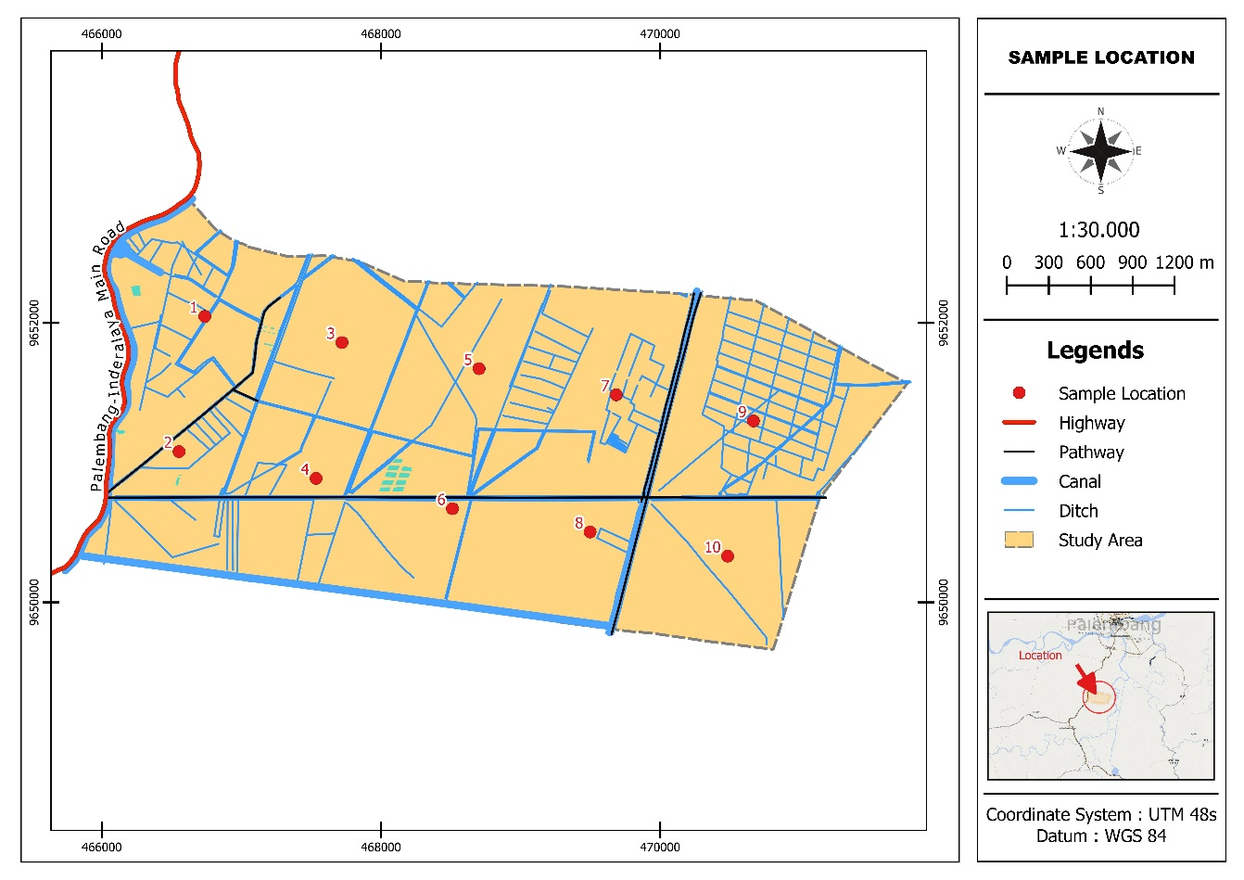
Figure 2. Distribution of Potentially Suitable Land for Wetland Rice Cultivation
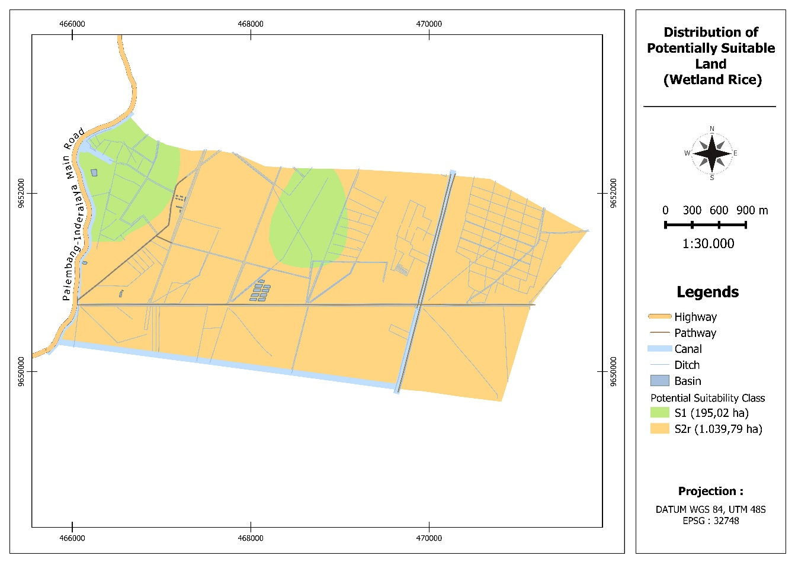

Figure 3. Distribution of Potentially Suitable Land for Dryland Rice Cultivation
